**ZUITT NOTES – DAY 19 2**/2/2023



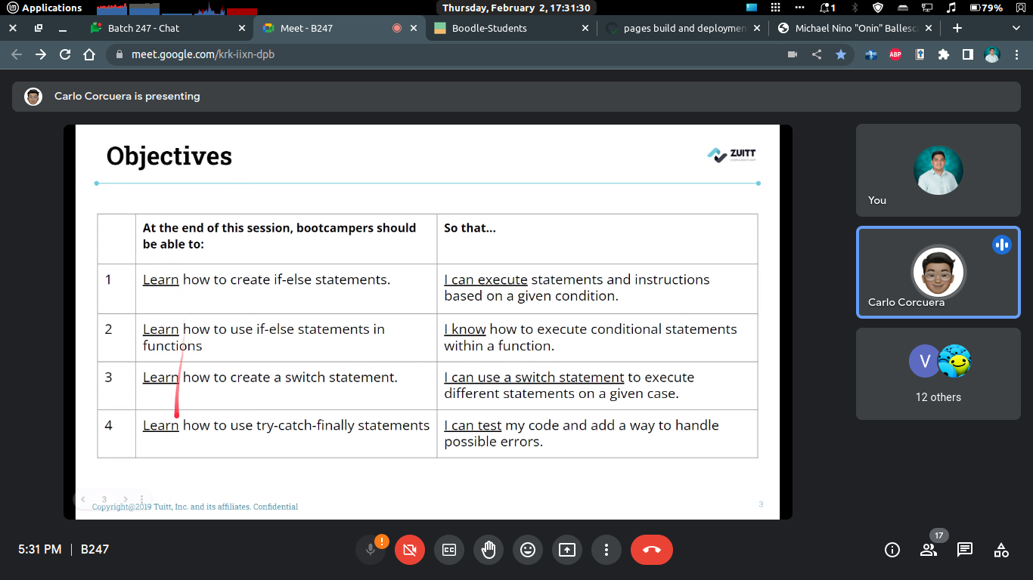

Alternative to console.log

- console.warn

parseInt() method is used to convert string to integer

toString() is to convert integer to string

ternary statement example

[condition] ? [true] : [false]

“?” = if

“:” = else